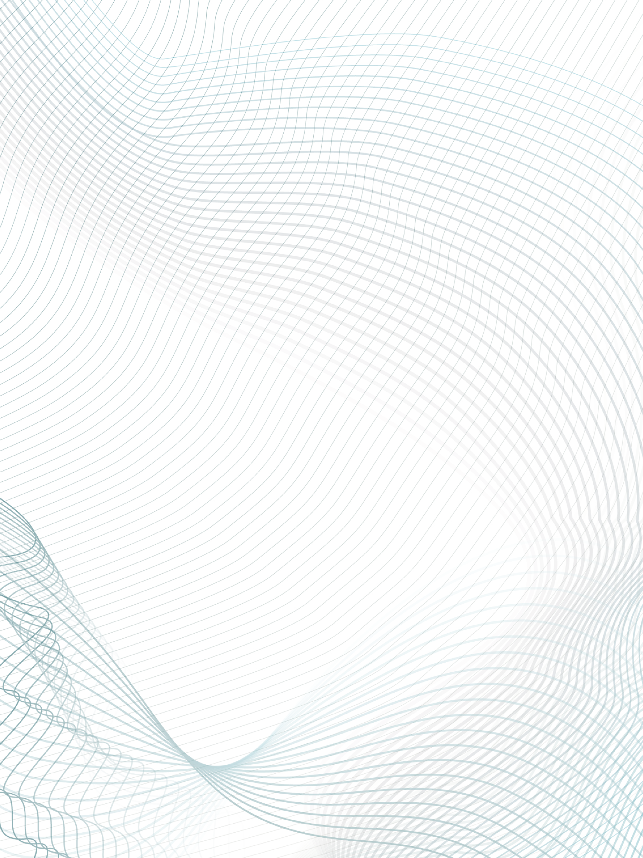

|  |  |  |  |  |  |  |  |  |
| --- | --- | --- | --- | --- | --- | --- | --- | --- |
|  | | | | | | | | |
|  | | The Social Dilemma | | | | |  | |
|  |  | | | | | | |  |
|  | | | |  |  | | | |
|  | | | | Sterre Walta |  | | | |
|  | | | | 20/03/23—Breda University of Applied Sciences—Data Science & Artificial Intelligence |  | | | |
|  | | |  | | |  | | |



|  |  |  |  |  |  |  |  |  |
| --- | --- | --- | --- | --- | --- | --- | --- | --- |
|  |  | | |  |  | | |  |
|  | SUMMARY | | | | | | |  |
|  |  | | |  |  | | |  |
|  |  | |  | | |  | |  |
|  |  |  | "The Social Dilemma," a Netflix original movie, features staff interviews who have previously worked for various social media sites like Google, Facebook, Instagram, etc. These ex-social media employees described how social media uses algorithms that encourage consumers to become app addicts. However, they brought up the possibility that these actions would be unethical given the damaging effects social media, particularly for teenagers, can have on users' mental and physical health. | | |  |  |  |
|  | | | | |
|  |  |  |  |
|  |  |

**WHY THIS DOCUMENTARY?**

|  |  |  |  |  |  |  |
| --- | --- | --- | --- | --- | --- | --- |
|  | |  |  |  |  | |
|  | I wanted to work on some extracurricular activities during this block. Because we began this block by focusing on ethical artificial intelligence, I carefully chose "The Social Dilemma" from a list of artificial intelligence documentaries. The unethical consequences of social media's recent upsurge are discussed in this documentary. Also, this documentary talks about young people's mental health, which I find interesting because it was widely reported following the Coronavirus that many young people are struggling with their mental health.  **MY REVIEW** | | | | |  |
|  | The documentary movie delivers an eye-opening insight into the ways in which our brains are being constantly manipulated and even rewired by sophisticated algorithms. The primary goal of these algorithms is to grab our attention and entice us to make purchases, but the impact of these manipulations runs deeper than that.  These algorithms not only target our consumer behaviour but also influence our perspectives and attitudes toward the world, ourselves, and others around us. Through the use of targeted content and personalized recommendations, these algorithms can skew our understanding of reality, often promoting distorted ideas and creating an illusion of a world that doesn't exist.  This manipulation of our cognitive processes can have far-reaching consequences, shaping our beliefs and values in subtle yet significant ways. It can create echo chambers, reinforcing our existing beliefs and biases and shutting us off from alternative viewpoints. It can also fuel the spread of misinformation and fake news, further eroding our collective sense of truth and reality.  The movie's message is clear: we need to be aware of the impact of these algorithms on our brains and take proactive steps to counter their influence. This requires a collective effort from tech companies, governments, and individuals to ensure that the algorithms are transparent and designed with ethics and user well-being in mind. Only then can we hope to regain control over our cognitive processes and make informed choices about our lives and the world around us.  The documentary sheds light on the reason behind the addiction to digital devices among a large number of people. It's revealed that advanced algorithms are being used to identify users, and their attention is then being skillfully manipulated to keep them logged in, engrossed, and prepped for targeted news feeds and advertisements. Those strikingly precise personalized recommendations that we see on our screens are a clear indication of how search engines and social media platforms have transformed into a highly sophisticated surveillance mechanism, jeopardizing user privacy on a constant basis.  Towards the conclusion of this Netflix documentary, the audience is confronted with a series of thought-provoking moments. It is revealed that a significant number of individuals who are employed in the tech industry, including those who work for prominent companies such as Google, Facebook, Twitter, Instagram, and other platforms, have made the decision not to allow their own children to use social media platforms. Additionally, they are known to restrict the amount of time their children spend on screens, and they actively discourage the use of digital devices among anyone under the age of 16.  What's more, these industry professionals have adopted certain measures to reduce their own reliance on technology. Some have gone so far as to disable notifications from social media applications or delete them entirely from their devices. Such actions are driven by a concern for the potentially harmful effects of social media and technology on individuals' mental health and well-being.  These sobering moments compel us to reflect on the double standards that exist in the tech industry. It's concerning that while these individuals are aware of the negative impacts of social media and screen time, they continue to market these products to the general public. This raises questions about the ethics and responsibility of tech companies and their employees in addressing the potential harms of their products.  As The Social Dilemma shows, entertainers are in no rush to hold us, or themselves, accountable. | | | | |  |

**SOURCES**

* LaunchPad, B. (2020, November 2). *3 Things We Learned About Social Media from Netflix’s “The Social Dilemma” - Blackstone LaunchPad*. Blackstone LaunchPad. <https://launchpad.syr.edu/3-things-we-learned-about-social-media-from-netflixs-the-social-dilemma/>
* Minow, N. (2020, September 8). *The Social Dilemma movie review (2020) | Roger Ebert*. Roger Ebert. <https://www.rogerebert.com/reviews/the-social-dilemma-movie-review-2020>
* *The Social Dilemma | Film Review | Spirituality & Practice*. (n.d.). <https://www.spiritualityandpractice.com/films/reviews/view/29056/the-social-dilemma>
* Turner, L. J. (2020, September 10). *The Social Dilemma will terrify you into deleting your social media accounts*. Digital Spy. <https://www.digitalspy.com/tv/ustv/a33978478/social-dilemma-netflix/>

|  |  |  |  |  |
| --- | --- | --- | --- | --- |
|  |  |  |  |  |